Color codes for the wires and pins for our Binary™ 3P XLR Female to Male Cable with Gold Plated Contacts. (B6-XLR-3FM-XXFT)
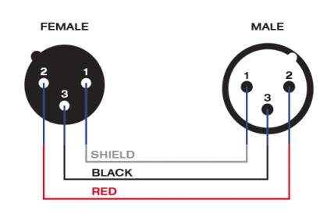

Note: Line one (1) has ground connection.

